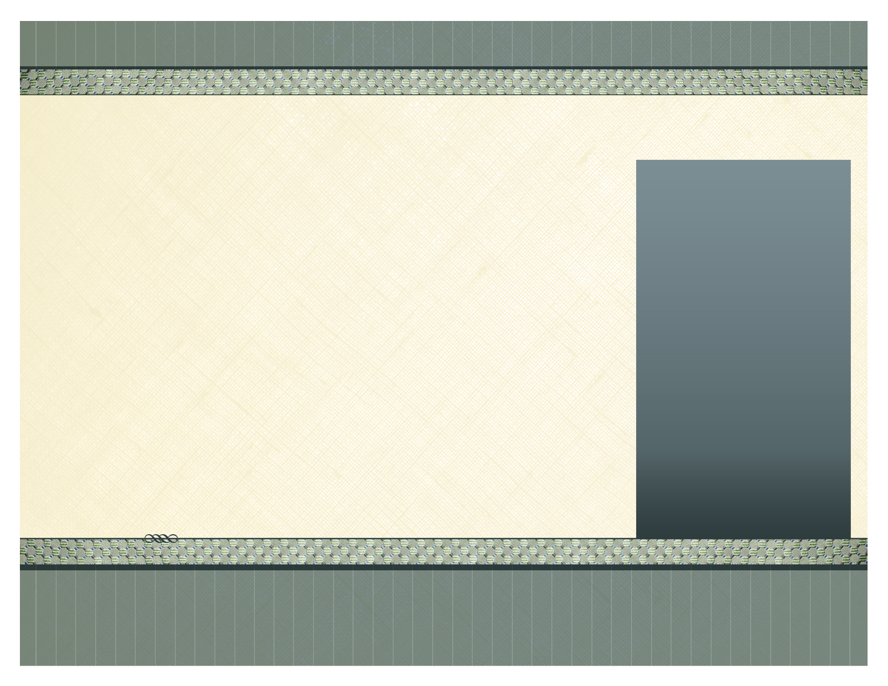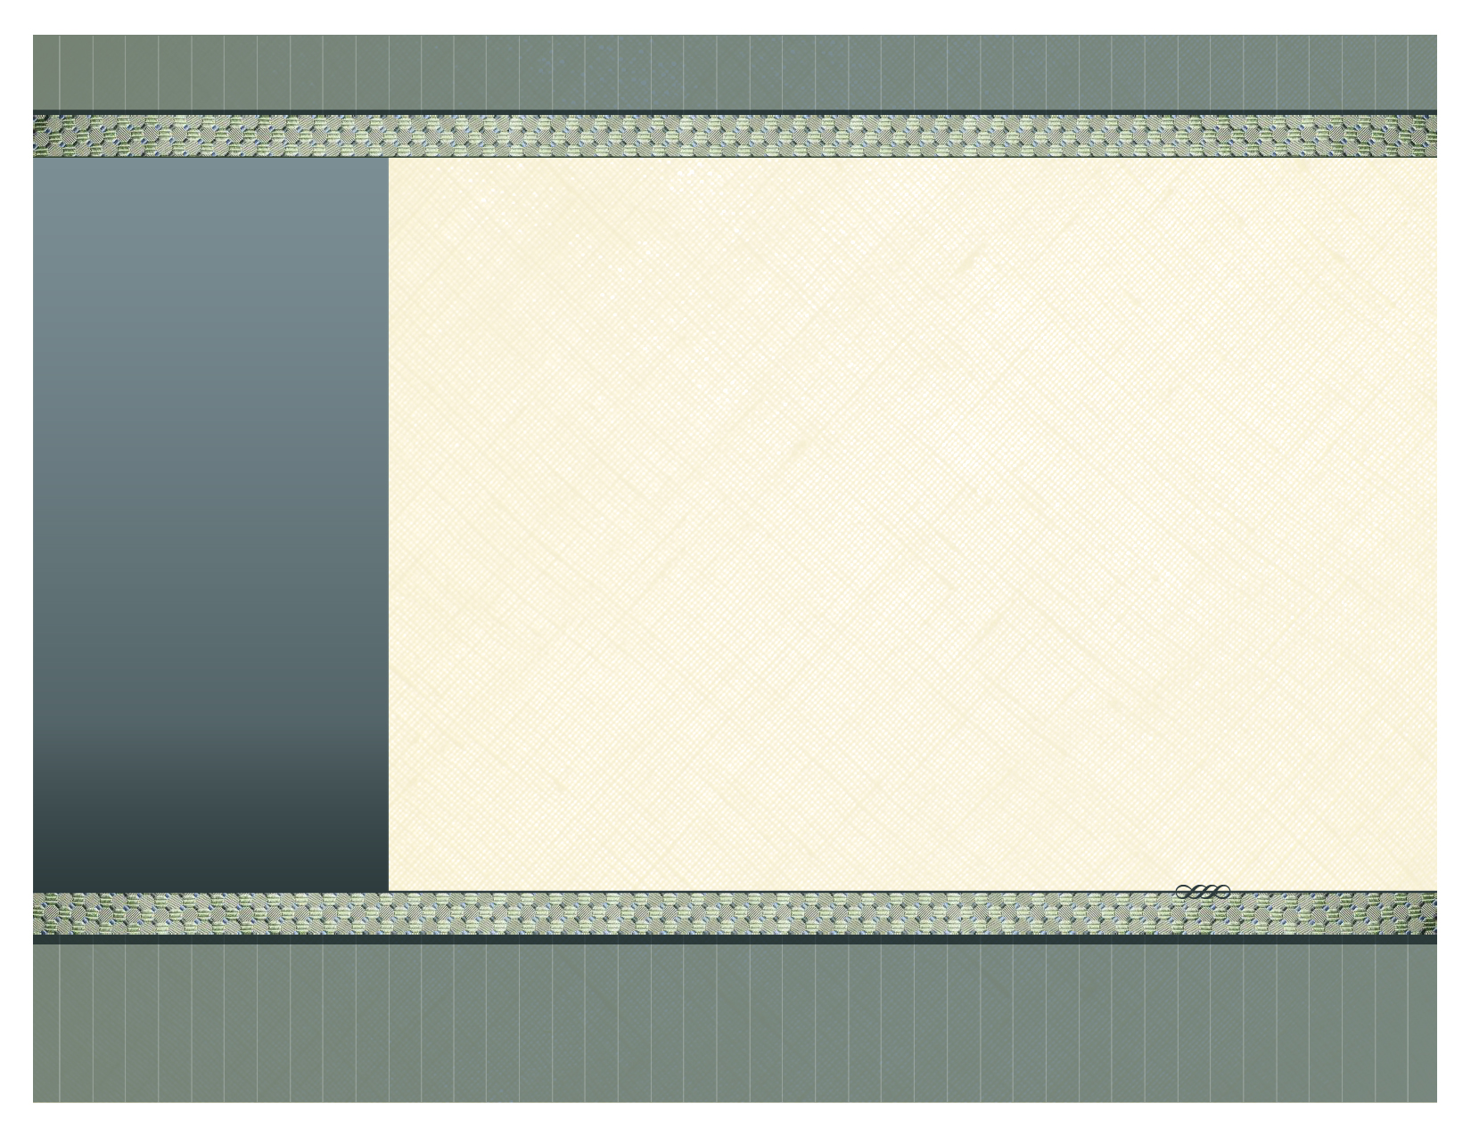

Price includes all importation, delivery to your property, installation, duty costs and VAT.

TERMS ...

50% down payment, and 50% when everything is delivered and fitted.

AIGA Tropical Living

­

The Living Room Master Bedroom

1 x Dining Table 160 x 80 cm (Ex) 1 x Banana Leaf Double Bed & Mattress

6 x Banana Leaf Dining Chairs 2 x Banana/Mahogany Bedside Tables

1 x Mahogany TV Sideboard 2 x Bedside Lamps

1 x Rounded Book Case 1 x Writing/Vanity Desk

1 x Banana Leaf Sofa 250 cm 1 x Banana Leaf Chair

1 x Banana Leaf Sofa 200 cm 1 x Banana Leaf Mirror 80 x 80

1 x Banana Leaf Coffee Table 1 x Floor Rug

1 x Banana Leaf Standing Lamp 1 x Long Banana Leaf Mirror 170 x 80

1 x Floor Rug 1 x Painting

2 x Paintings

1 x Nest of Side Tables Second Bedroom

1 x Table Lamp 2 x Banana Leaf Single Bed & Mattres s

2 x Decorative Table Bowls 2 x Banana Leaf Bedside Tables

2 x Paintings 2 x Bedside Lamps

1 x TV LCD 32” 1 x Long Banana Leaf Mirror 170 x 80

1 x DVD Player 1 x Floor Rug

1 x Painting

Third Bedroom

1 x Banana Leaf Double Bed & Mattress

2 x Banana/Mahogany Bedside Tables

2 x Bedside Lamps

1 x Long Banana Leaf Mirror 170 x 80

1 x Painting

Outdoor Furniture

1 x Teak Table 180 x 100 (Extendable)

6 x Teak Foldable Dining Chairs

5 x Sunbeds & Cushion

1 x Food & Drinks Trolley

1 x Teak Bench & Cushion

2 x Deck Chairs

1 x Coffee Table

Paradise Beach Resort – Furniture Inventory T3 (Accessories package also available – see Accessories Brochure)

Right of the main square, Santa Maria, Sal,

Tel: 00238 – 9183330 or 00238 - 9859318

[www.aigacaboverde.com](http://www.aigacaboverde.com) Facebook: Aigagroup Caboverde

AIGA Cabo Verde S.A.

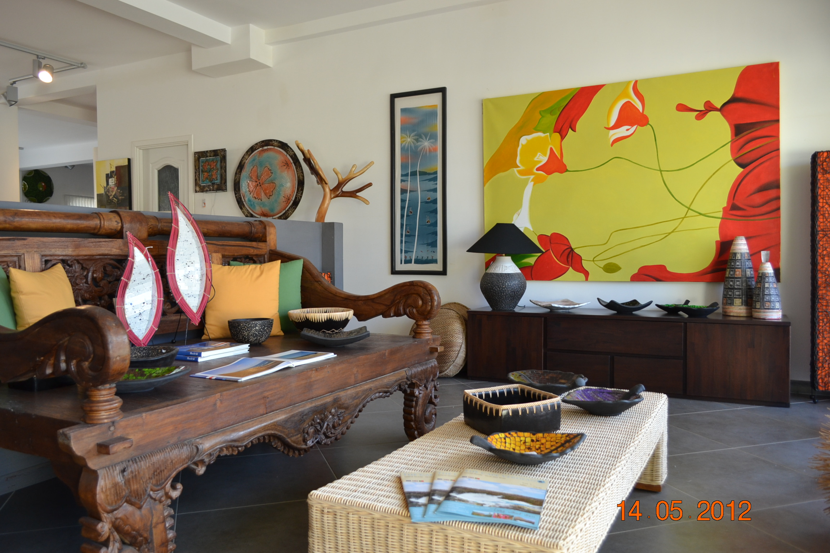

Master Bedroom Outdoor Furniture

1 x Banana Leaf Double Bed & Mattress 1 x Teak Folding Dining Table 140 x 80

2 x Banana/Mahogany Bedside Tables 6 x Teak Folding Chairs

2 x Bedside Lamps 2 x Teak Deck chairs with cushion

1 x Writing/Vanity Table 1 x Teak Bench with cushion

1 x Banana Leaf Chair

1 x Banana Leaf Mirror 80 x 80

1 x Floor Rug

1 x Long Banana Leaf Mirror 170 x 80

Second Bedroom

2 x Banana Leaf Single Beds & Mattress

2 x Banana Leaf Bedside Tables

2 x Bedside Lamps

1 x Long Banana Leaf Mirror 170 x 80

1 x Painting

The Living Room

1 x Extendable Dining Table 140 x 80 cm

6 x Banana Leaf Dining Chairs

1 x Mahogany TV Sideboard

1 x Rounded Book Case

1 x Banana Leaf Sofa 250 cm

1 x Banana Leaf Sofa 200 cm

1 x Banana Leaf Coffee Table

1 x Banana Leaf Standing Lamp

1 x Floor Rug

2 x Paintings

1 x Nest of Side Tables

1 x Table Lamp

2 x Decorative Table Bowls

2 x Paintings

1 x TV LCD 32”

1 x DVD Player

**Paradise Beach Resort – Furniture Inventory T2**

(ACCESSORIES PACKAGE ALSO AVAILABLE – See Accessories Brochure)

Price includes all importation, delivery to your property, installation, duty costs and VAT.

TERMS ...

50% down payment, and 50% when everything is delivered and fitted.

AIGA CABO VERDE S.A

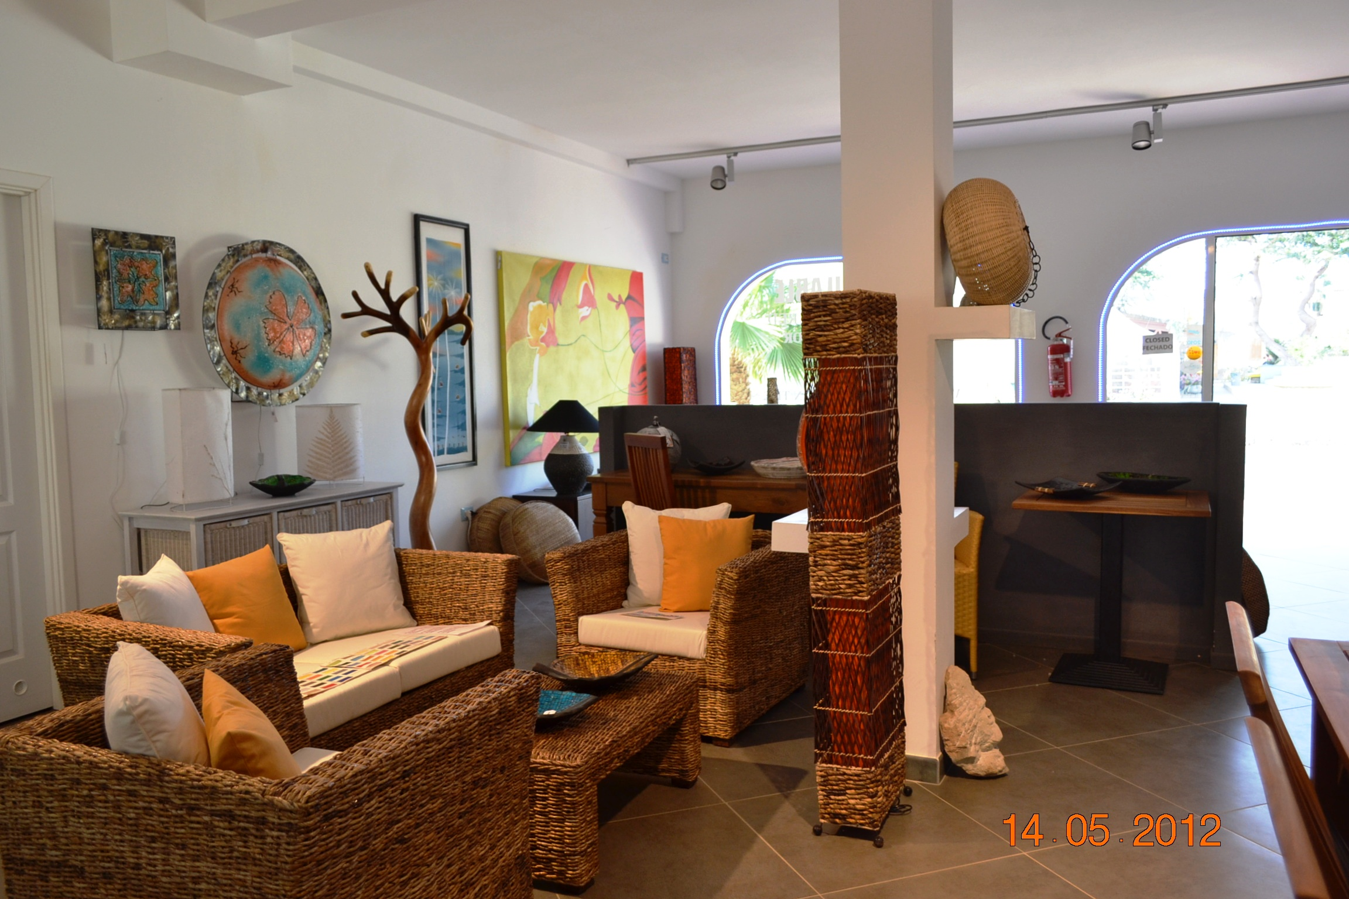

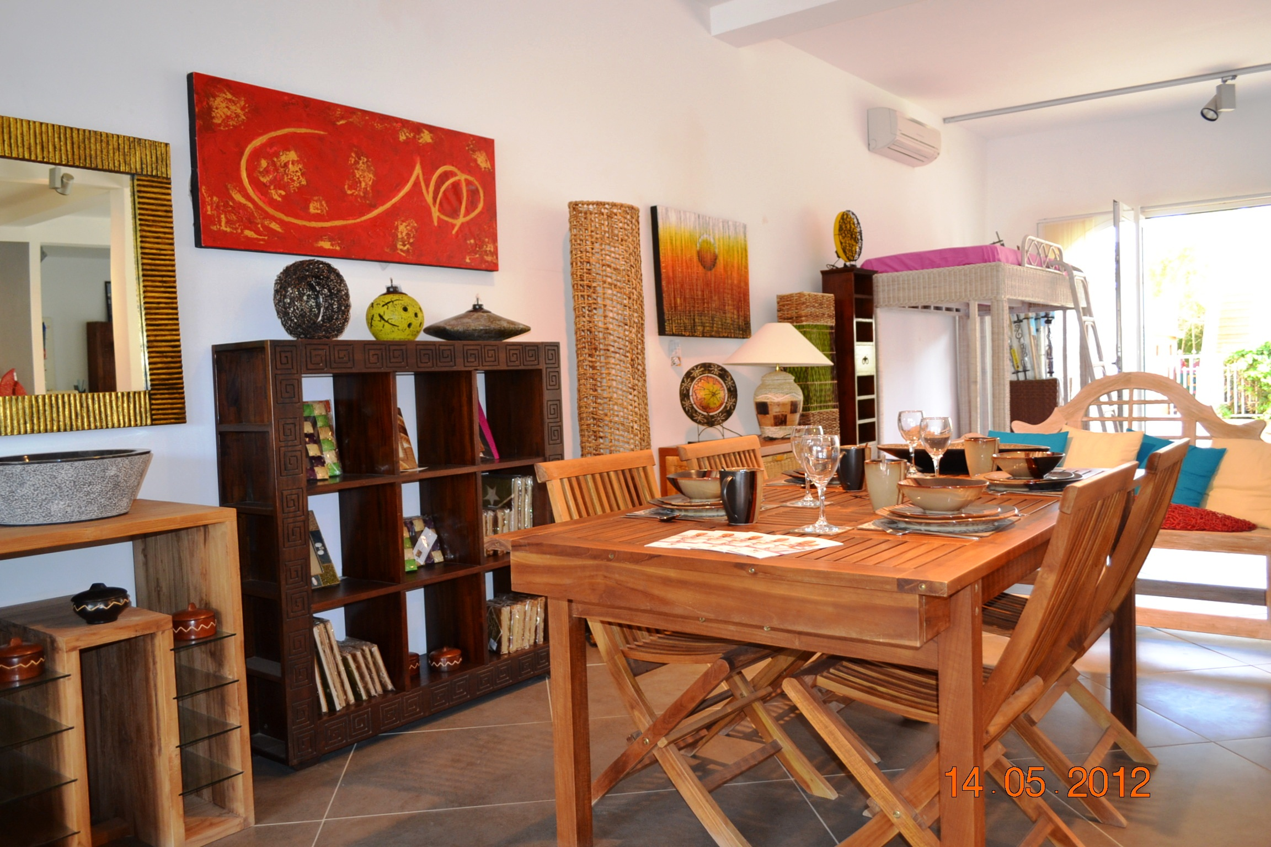

Right of the main square, Santa Maria, Sal

Tel: 00238 – 9183330 or 00238 - 9859318

[www.aigacaboverde.com](http://www.aigacaboverde.com) Facebook: Aigagroup Caboverde

Photos of AIGA showroom in Santa Maria, Sal